EXPT NO:1 | Implementation of data charts
DATE: 06.01.2026 | Implementation of data charts

PRE-LAB QUESTIONS (PROVIDE BRIEF ANSWERS TO THE FOLLOWING QUESTIONS)

- How can visualization help an academic institution improve student outcomes?
Ans - Visualization helps easily identify weak subjects, performance trends, and student progress so teaching strategies can be improved.

- Which chart types are suitable for comparing subject-wise performance?
Ans - Bar charts are best for comparing subject-wise performance.

- What type of data scale is used for student marks?
Ans - Student marks use a ratio scale because they have a true zero and measurable differences.

- Why should raw academic data be cleaned before visualization?
Ans - Data cleaning removes errors and missing values to ensure accurate and meaningful visualizations.

- How does visualization support evidence-based decision making?
Ans - It presents data clearly, helping institutions make informed decisions based on actual performance patterns.
IN-LAB EXERCISE:

OBJECTIVE:
To design appropriate data charts to analyze and compare academic performance indicators.

SCENARIO:
An autonomous engineering college wants to analyze internal assessment performance of first-year students across five subjects to identify difficult courses and improve teaching strategies.

IN-LAB TASKS (Using R Language)
- Load required R libraries (ggplot2, dplyr)
- Import dataset using read.csv()
- Perform basic data preprocessing
- Create bar chart for subject-wise average marks
- Generate line chart for performance trend across tests
- Plot pie chart for grade distribution

(CODE: CONATAINS STUDENT ROLL NOS
SCREENSHOT OF CODE
SCREENSHOT OF OUTPUT)

CODE:

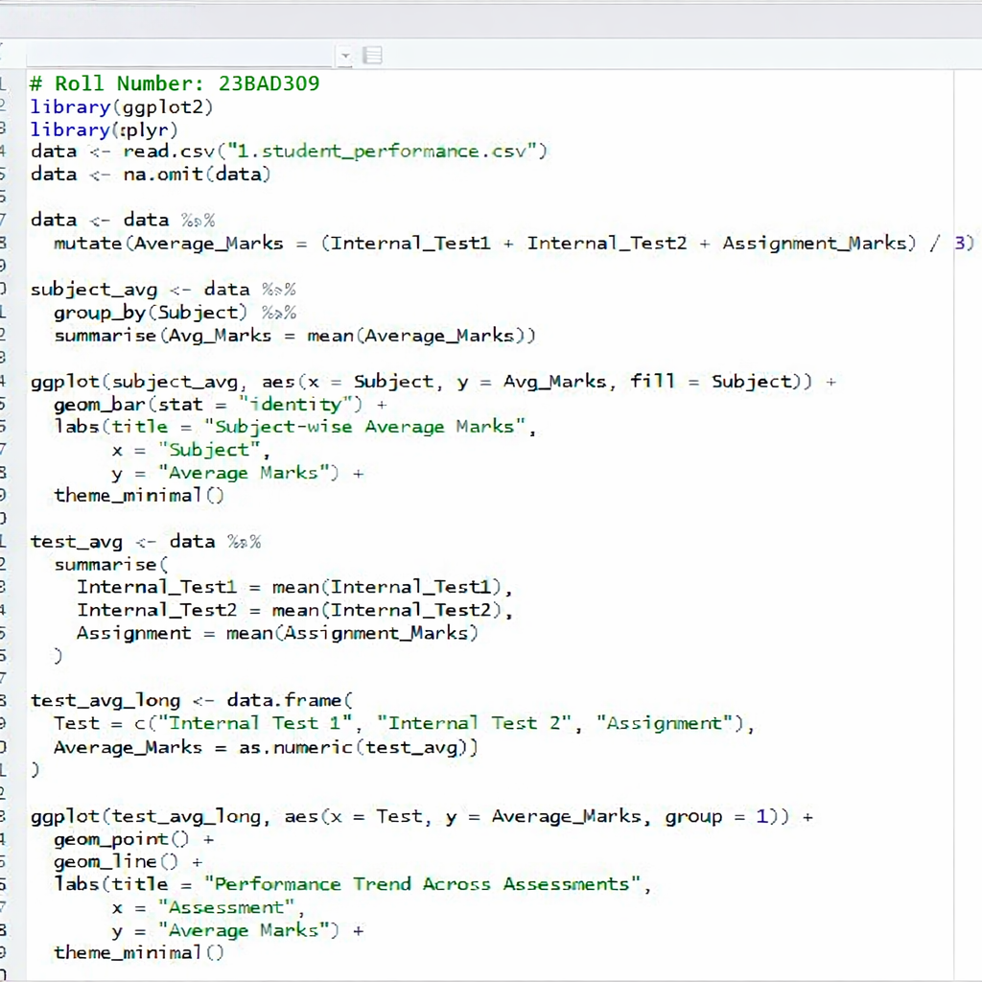

OUTPUT:

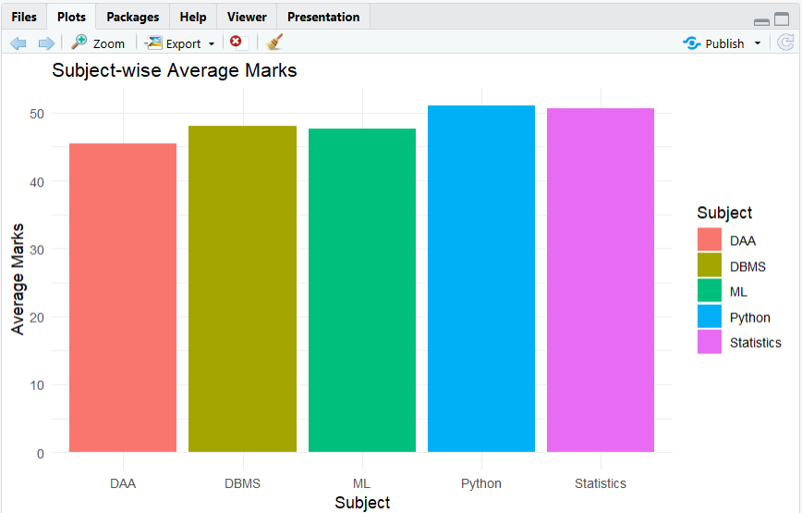

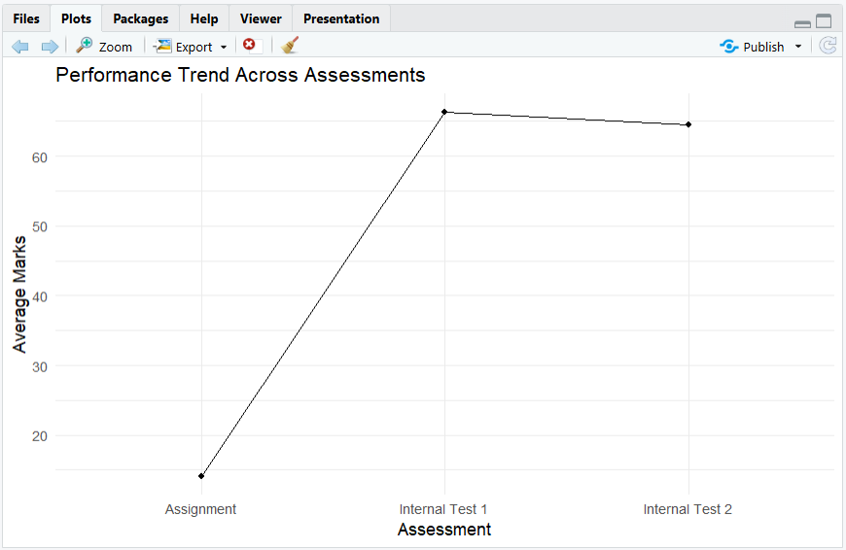

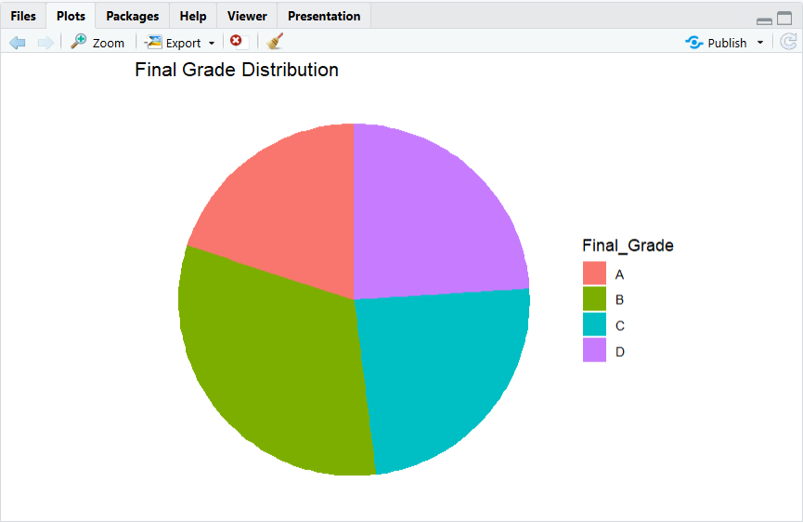

POST-LAB QUESTIONS (PROVIDE BRIEF ANSWERS TO THE FOLLOWING QUESTIONS)

- Which subject shows consistently low performance and why?
Ans - DAA shows the lowest average marks, indicating students find it more difficult compared to other subjects.

- Why is a line chart suitable for trend analysis?
Ans - A line chart clearly shows changes in performance across assessments over time.

- What limitations does a pie chart have in analytics?
Ans - Pie charts do not show exact values clearly and are not suitable for detailed comparisons.

- How can this analysis help curriculum planning?
Ans - It helps identify weak subjects and assessments, allowing curriculum and teaching methods to be improved.

- How can such visualizations be integrated into AI-driven academic analytics
Ans - They can be used as inputs for AI models to predict performance, detect risk students, and recommend interventions.

ASSESSMENT
Description | Max Marks | Marks Awarded
Pre Lab Exercise | 5
In Lab Exercise | 10
Post Lab Exercise | 5
Viva | 10
Total | 30
Faculty Signature

